Serena  
 Alarm  
 System  
 3-Password Alarm System

**Table of contents**

1. Introduction………………………………………3
2. Options menu………………………………………...4
   * 1. CHANGING PASSWORDS………………...……5-8
     2. Set auto-arm time…………………………...9
3. arm menu……………………………………………..10-11
4. Customize your system…………………………..12
5. Default passwords………………………………..13

INTRODUCTION

The SERENA Alarm System is a 3-Password Alarm Control Panel that can be used as the “brain” of any alarm system.

The control panel is made with an Arduino Mega at its core and a 3.2” TFT LCD Touch screen with its shield attached to the board.

As mentioned above, the alarm uses 3 passwords:

* A 4-digit pass to arm the system
* A 5-digit pass to partially disarm the system (optional)
* And a 6-digit pass to completely disarm the system

The system also has an auto-arm function which can be turned on/off by the user. This function uses the 5-digit password and can arm the system automatically after the amount of seconds that the user desires.

Furthermore, the control panel can also be portable and can work with a Bluetooth module (HC-05). More on that on Section (number): Customize your system.

Last but not least, the user has the option to use a real-time clock/date module (DS3231) to display the current time and date.

options menu

The options menu is the top button in the Main Menu, as seen in the image below:

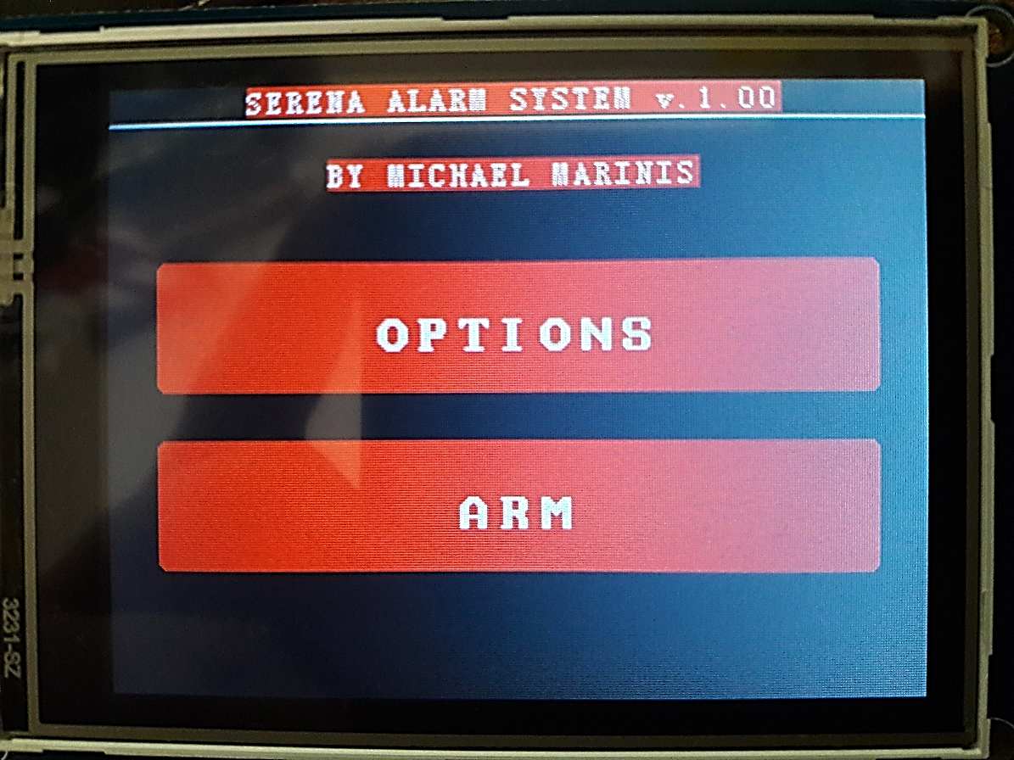

Figure 1: Main Menu

The Options Menu contains all the functions to change all 3 passwords, enable Auto-Arming, changing the Auto-Arm time, change Date/Time and much more.

By touching the button, the screen will show the first page of the options menu. The user can then see 4 buttons:

* SET MANUAL-ARM PASSWORD
* SET ARM PASSWORD
* BACK
* NEXT

ChangING passwords

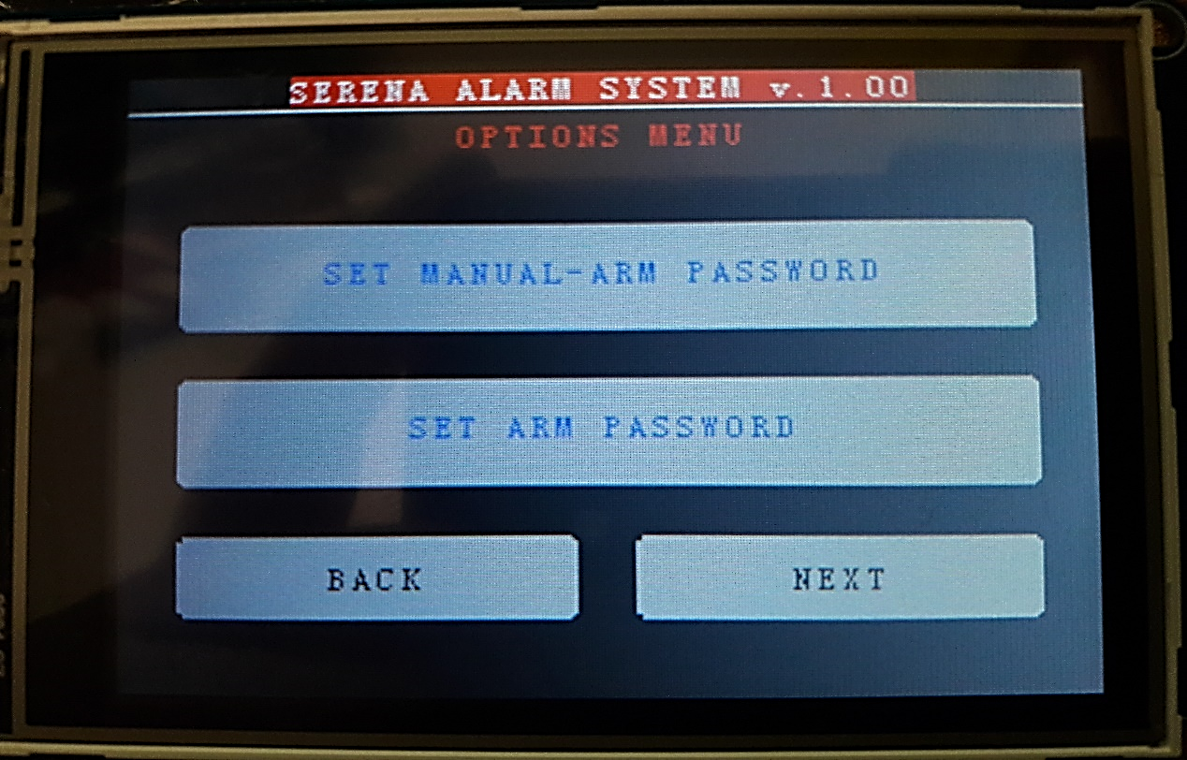

Figure 2: The first page of the options menu

This section describes how can the user change every available password.

The buttons that are related to the passwords are the following:

* SET MANUAL-ARM PASSWORD: 6-digit pass, used to completely disarm the system. **Default: 111111**
* SET ARM PASSOWORD: 4-digit pass, used to arm the system. **Default: 1111**
* SET AUTO-ARM PASSWORD: 5-digit pass, used partially disarm the system. This will put the system in the auto-arm phase, a countdown will start and the system will automatically arm itself when the countdown is finished. The time is set by the user. **Default password: 11111**

When any of these buttons are touched, the user will be asked to enter the current password that he wants to change. Then, the keyboard will appear on screen.

When the keyboard is on screen, the user can enter the required password. It should be noted that every password change, follows the exact same process.

As seen in the picture below, there are three more buttons except from the numbers: the “CLEAR” button, the “OK” button and the “BACK” button where they clear the user’s input, checks if the password is correct and sends the user to the options menu respectively.

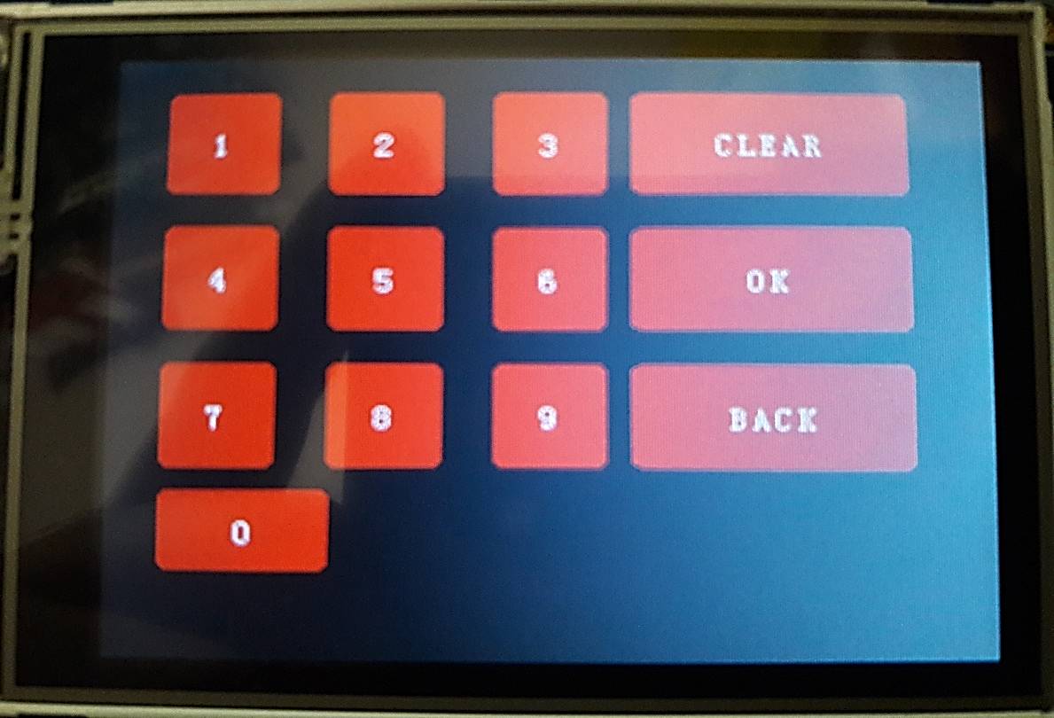

Figure 3: The keyboard

When the user finishes entering the password, the program will check if the password is correct and if it is, it will prompt the user to enter a new password as seen in the next image:

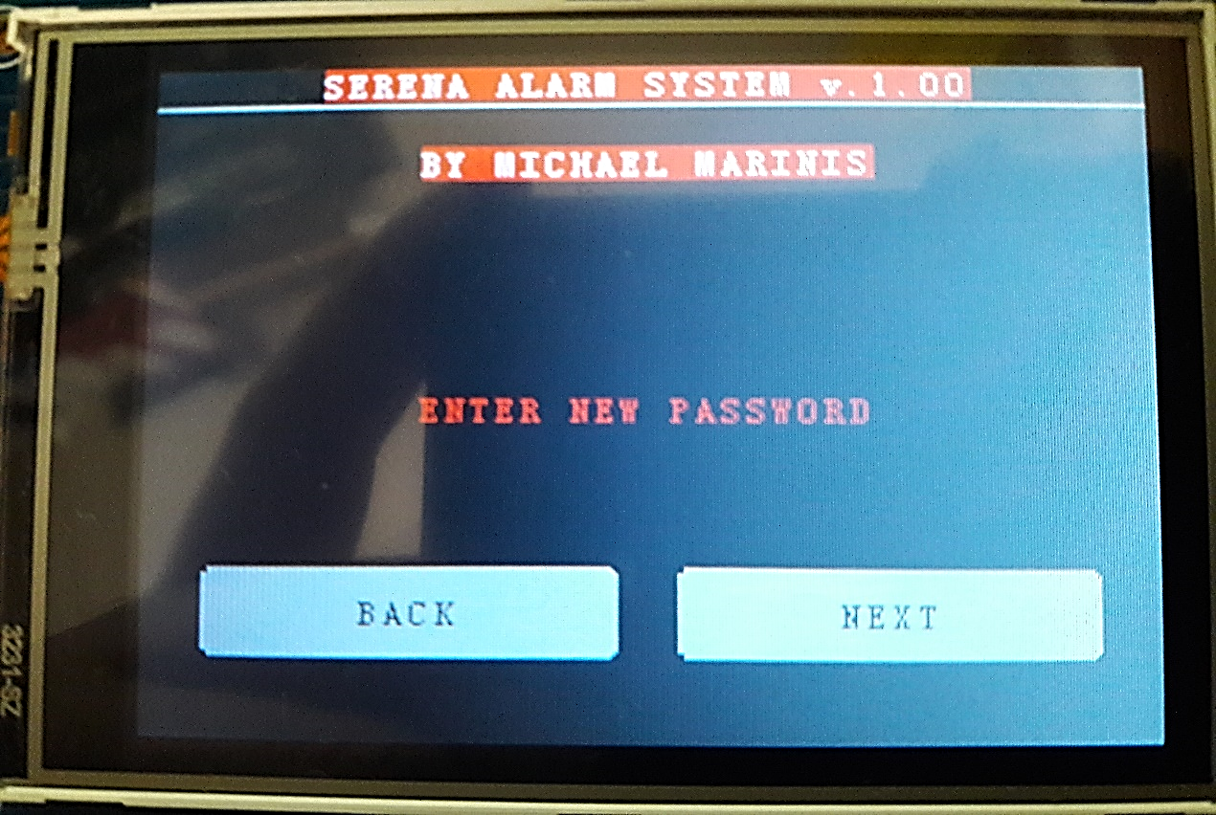

Figure 4: The system asks the user to enter a new password

The keyboard will appear again and the user must enter the new password. The same buttons exist as before. When the user is happy with their choice, they must press “OK” and then the system will show the password to the user, asking if the password is ok.

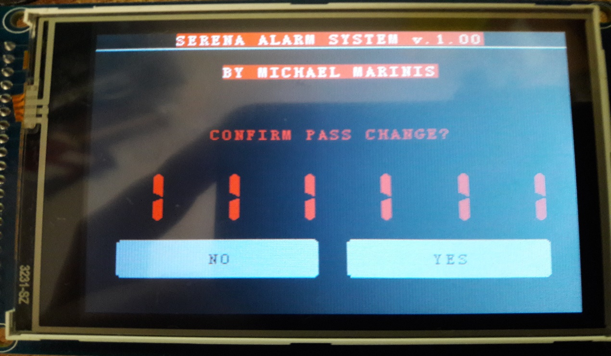

Figure 5: Confirmation of the new password

If the “YES” button is touched, the new password will be set and the user will be prompted to the appropriate page of the Options Menu.

Otherwise, the user will be prompted to the keyboard to re-enter the new password.

Set auto-arm time

This short section describes the process that must be followed in order to change the auto-arm time.

As stated in the <<Introduction>> section, the system can be auto-armed after a short period of time. This time can be set by the user.

To set the auto-arm time, the user must go to the second page of the Options Menu and touch the “SET AUTO-ARM TIME” button.

When touched, the system will show the current time in seconds and prompt the user to enter the new time. When the new time is entered, the system will show it to user and ask if everything is OK. If it is, the user touches the “YES” button and the new time is set. Otherwise, the user will be prompted to the keyboard to re-enter the new auto-arm time.

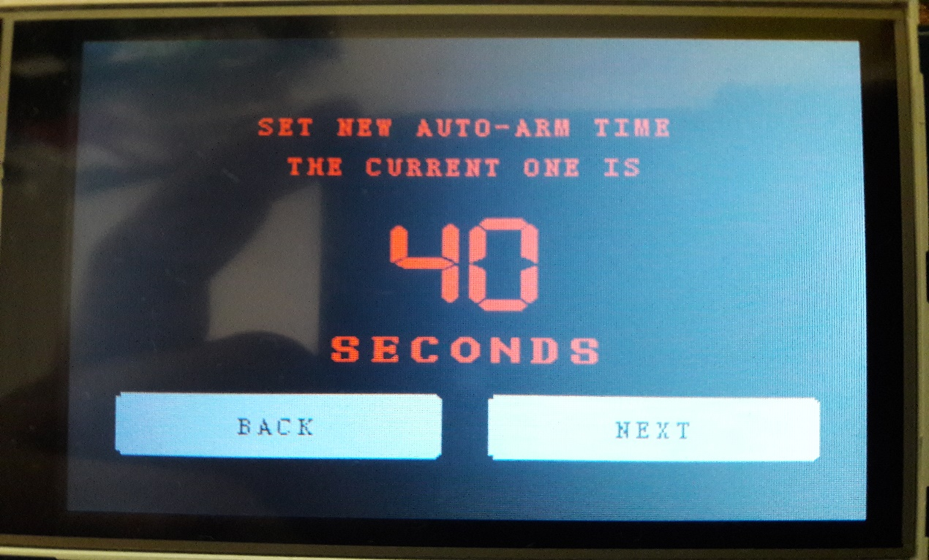

Figure 6: Screen after the user enters the SET AUTO-ARM TIME menu.

arm menu

This section describes how the arm menu works in the SERENA Alarm System. The user can arm the system after touching the “ARM” button in the Main Menu.

The system will ask for the 4-digit pass to be entered. Once the user enters the password, the system will be armed.

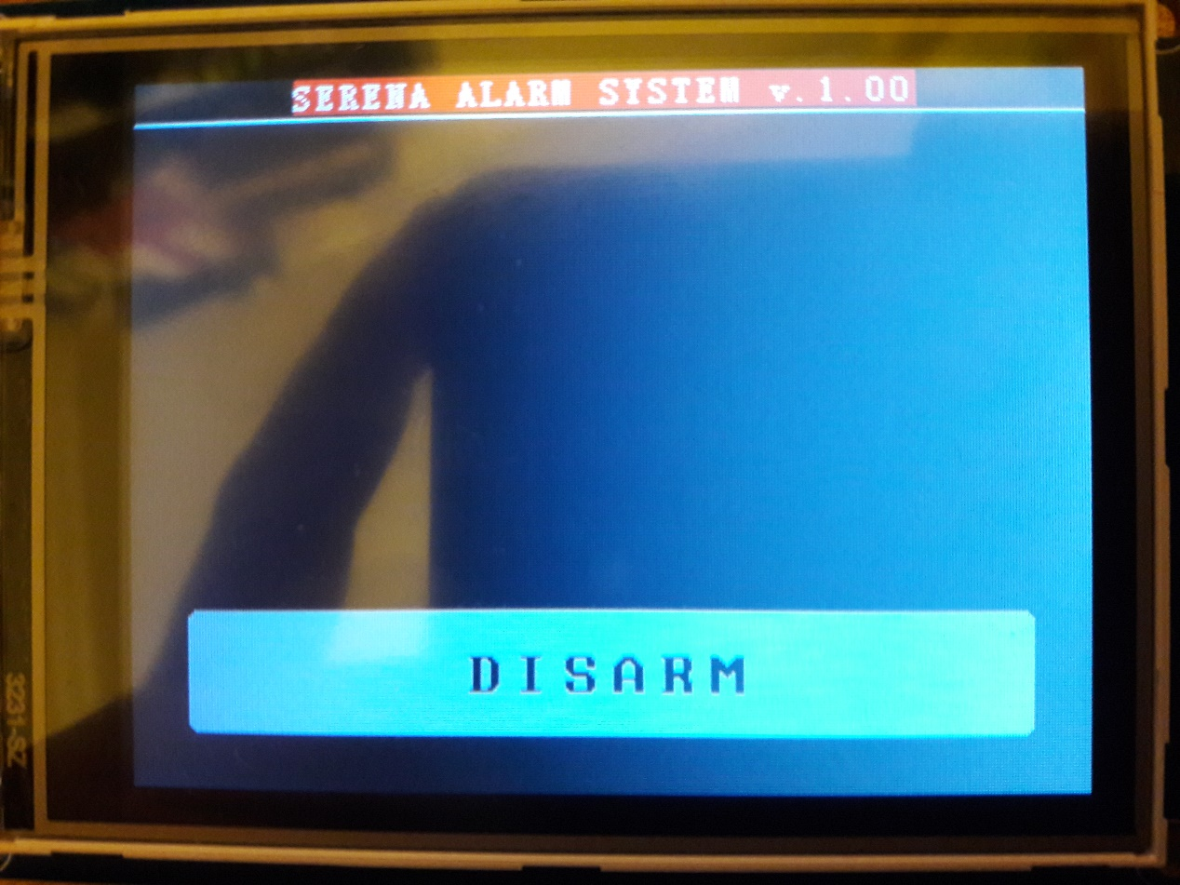

Figure 7: Screen after the system is armed

After the system is armed, a screen will appear with the current date/time and a “DISARM” button on the bottom of the screen.

When the user touches the button, the keyboard will appear and the user must enter the 5-digit pass if the auto-arm is ON, or the 6-digit pass if the auto-arm is OFF.

In the case the auto-arm is ON and the user enters the 5-digit pass, the system will start the countdown with the time that the user has entered. Once this countdown ends, the system will be automatically armed.

If the user wants to completely disarm the system, he/she must touch the screen again in order to show the keyboard and enter the 6-digit pass. Once the password is entered, the system will be completely disarmed and the user will be prompted to the main menu.

CUSTOMIZE YOUR SYSTEM

The SERENA Alarm System can be installed in a stable place (e,g, on a wall) and send signals when being wired to a siren, or can be portable and send those signals via Bluetooth.

SERENA’s program is designed to support a Bluetooth module (preferably the HC-05) which will send the appropriate signal from the master module to the slave module when the system is armed/disarmed.

This can make the system portable and can be moved anywhere, of course with the right battery source and save the user some valuable time and wiring.

DEFAULT VALUES

**6-digit password: 111111**

**5-digit password: 12345**

**4-digit password: 1234**

**Default auto-arm time: 40 seconds**